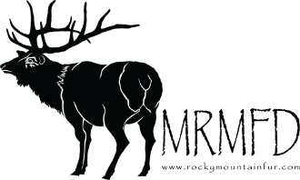

Wholesale Turning and Fleshing Price List
Capes
Antelope | 51.20
Deer | 51.20
Sheep | 51.20
Elk | 106.00
Oryx | 106.00
Moose | 170.45
Mountain Goat | 48.75
Life Sizes
Deer | 140.05
Elk | 340.70
Moose | 474.60
Black Bear | 170.45
Mountain Lion | 107.15
Sheep | 140.05
Wolf | 118.10
Mountain Goat | 158.30
Grizzly | 267.70
Removal of Paws, Hooves and Tails | 12.30 | (A Piece)
Removal of Skulls | 24.45
Full Skins
Buffalo/Beef | 206.95
Elk | 48.75
Deer | 24.45
Antelope | 24.45
Moose | 51.20
Furs
Fox/Coon/Badger/Coyote/Bobcat | 97.35
Removal of Paws and Tails | 6.15 | (A Piece)
Removal of Skulls | 14.70

Effective September 1, 2024

